**Creating The Dashboard**

Once you’ve created views on different tabs in Cognos analytics, you can pull them into a dashboard.

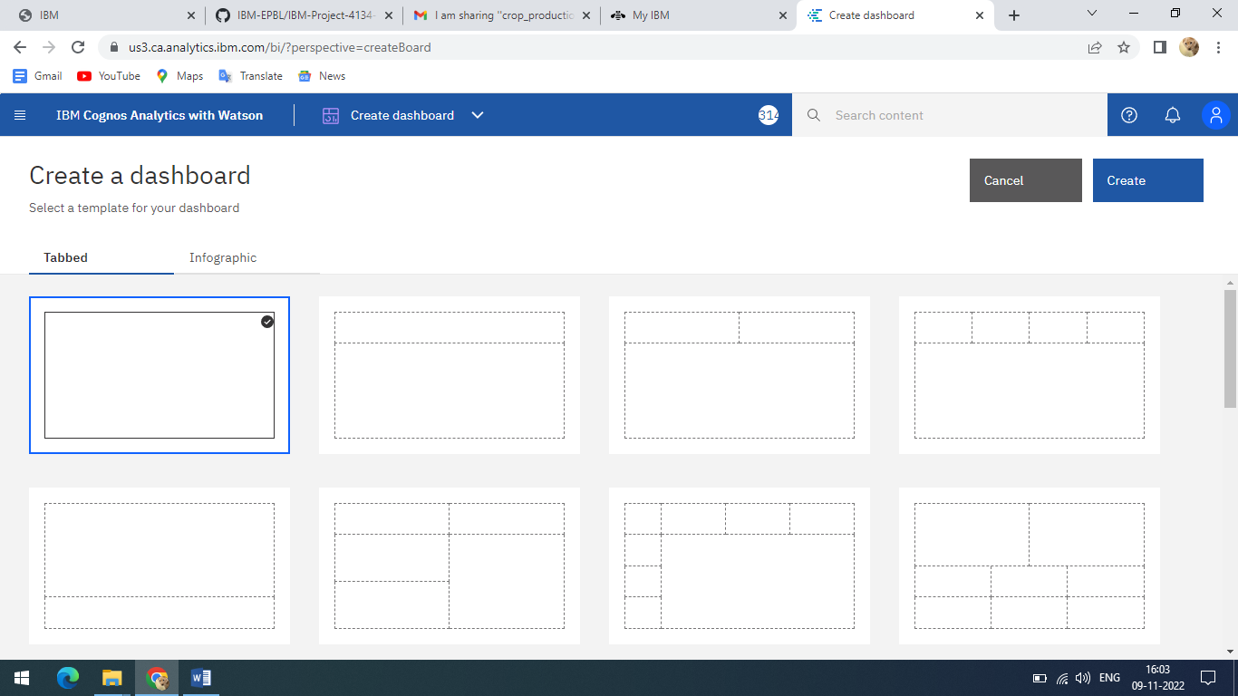

Final Output:

